The Express

Newsletter of the Tinplate Trackers, Austin, Texas
December 2003 – 41st^{h} Edition

A newsletter will be sent out every two months to the current members, past members, and visitors of the club. Please contact Ed Weltens at 512-250-0616 or E-Mail him at mailto:Ed.Weltens@sbcglobal.net if you have any information you would like to have included in future newsletters. All comments/submissions welcome!

From The Editor
Hi Tinplaters!

Here is the last newsletter for 2003. I hope the holidays have treated you well. I have really enjoyed getting to see more of you all this Fall and Winter as we have had or club layout at the Railyard. I think that having the layout set up there has been one of the best things we have done as a club. Thanks again to Craig Berry of the Collectible Caboose for arranging the space. Make sure you e-mail me the train related gifts you got over the holidays for the next newsletter. You can reach me at mailto:ed.weltens@sbcglobal.net

Regards,
Ed

PAST CLUB EVENTS

Austin Railroad Jamboree – November 1-2, 2003
By: Ed Weltens

Well I missed the jamboree again this year but from the reports I have heard it was a success. A large group of members set up our club layout at The Railyard in Cedar Park. Craig Berry of the Collectible Caboose arranged for this location for us in a former Real Estate office in the shopping center.

We set up a 7 x 2 L-shaped layout, including Adrian and Steve's siding and transfer table and our switching yard. It is long and narrow, but there is still space inside for us to move around.

We will leave our layout set up until just before the GATS show in January. If any member wants to get into the store to run trains, add scenery modules, etc. just contact Craig Berry at The Collectible Caboose (259-9494) to arrange to get access to the store.

Czhilispiel 31 – October 24-26, 2003

By: Ira Schneider

We spent the weekend of October 24 - 26 in Flatonia at the Czhilispiel. On Friday, we had a good crew to setup the layout, including Dwight Edens, Adrian Elliot, Randall Howell, Ira Schneider, and Bob Stettner. We also had some assistance from Tommy Shults and Randall's friend Terry. When we arrived, Tommy showed us the available space and asked if we could do an L-shaped layout to work around the Ntrack layout. I designed a 6x6 L-shaped layout to fit. You can see the layout diagram on the club web site. We completely assembled and tested the layout on Friday afternoon.

Saturday started out warm and humid. We had expected three members to run on Saturday (Dwight Edens, Ira Schneider, and Scott Smiley). I was pleasantly surprised when Mike and Hugh Pauwels showed up. We had four members and four tracks, so everyone could run as much as they wanted all day. We had been running trains all morning and half of the afternoon when I decided to run my freight train. The first thing I noticed was that the caboose kept derailing. Since this caboose is somewhat sensitive to track alignment, I just thought it was being finicky and took it off the train. I then noticed that the engine was also derailing occasionally, at around the same spot. After closely examining the track I found that one of the track pins was outside the rail at one of the bridge tracks.

We had been running from 10:00 AM until around 3:30 PM and didn't notice the problem. We stopped all trains for about 5 minutes, separated and reconnected the affected modules and started up again.
There were no other major problems for the rest of the day.

Early on Saturday morning, I decided to experiment with the MTH control system. I noticed at the previous show that MTH ProtoSound 2 engines were being recognized on track 3 but not on track 2. I determined that the MTH controller was still acting in the same manner. I switched track 2 from Variable Input/Output 1 to Variable Input/Output 2 on the MTH controller and tried again. The controller recognized and operated my ProtoSound 2 engines on track 2, as designed. I ran in DCS mode for the rest of the day.

On Sunday, which was cool and intermittently rainy, we had a large number of members (Rick and Ricky Dolifka, Adrian Elliot, Randall and Ryan Howell, Ira Schneider, Bob Stettner, and Ed Weltens). The only problem we encountered was a noticeable slow down on part of the layout. I disconnected and reconnected one of the Jones plugs and the situation improved a little. I think we need to clean all of the
Jones plugs again. In the morning I found that the MTH controller wouldn't recognize my engines on either track 2 or 3, so I took the entire MTH control system off line for the rest of the day. I will look at it again when we have the layout setup in Cedar Park. We also had a small burnout during the day. Around noon, most of us went outside to watch the Czhilispiel parade. When we came back inside there was a strong burning odor. We found the trolley car had derailed and shorted out its transformer. The transformer was smoking (and was VERY HOT). I eventually replaced it with one of the club's RW transformers and restarted running the trolley for the remainder of the day.

We had several unspectacular derailments, runaways, etc. during the weekend. At one point I heard a thump, turned around, and found the engine for my Amtrak train was in the middle of the passenger cars - pulling some and pushing the others. Apparently, three cars uncoupled from the train, the rest of the train made it all the way around the layout, and when they met (the thump I heard), they wayward cars stayed on the track and were just being pushed by the rest of the train.

We raffled off a Lionel Holiday Trolley Set. My wife, Lorraine Schneider, staffed the raffle table for most of the weekend. She sold $147 in raffle tickets. The trolley set was won by a resident of Flatonia who picked up his prize on Sunday afternoon. He was astounded when I called him and told him he had won the raffle.

Tommy tallied the number of visitors to the Civic Center building. On Saturday we had over 500 visitors to the model railroad layouts. On Sunday, the tally was over 300 at around 3:00 PM. (I didn't get the final tally). We rarely saw a "large" crowd of people, but there was a steady stream of visitors. I set up Bob Stettner's wireless camera on one of the trains and displayed the video on my laptop. People were
fascinated watching the "train's eye view" of the layout, as usual.

Overall, I think this was a terrific event. We all had fun, had plenty of time to run our trains, and were able to see the rest of the Czhilispiel (rides, carnival midway booths, food booths, arts and crafts booths, the parade, etc.). I even had time to participate in the 5K run on Saturday morning.

FUTURE CLUB EVENTS

Club Event Schedule
The following table shows the events and shows that the club has scheduled or is considering. If you have an event you want to have considered submit it to the club mail reflector at mailto:ttat-members@aoot.com
2004 Schedule
 | DATE | SHOW | PLACE | STATUS
 | Jan 3, 10-4p | Club Fun Run | Cedar Park Railyard | Confirmed
 | Jan 4,10-2:30p | Club Fun Run | Cedar Park Railyard | Confirmed
 | Jan 4, 2:30p | tear-down for GATS | Cedar Park Railyard | Confirmed
 | Jan 10,11 | GATS | Austin - Palmer Center | Confirmed
 | Feb 7,8 | SAMRA Train Show | Live Oak | Confirmed
 | March | Club Fun Run | Branch Creek Clubhouse | Pending
 | April | New Braunsfuls | Civic Center | Pending
 | May | Club Fun Run | Branch Creek Clubhouse | Pending
 | June 5,6 | GATS | Live Oak | Pending
 | July | Club Fun Run | Branch Creek Clubhouse | Pending
 | Aug. 21 | New Braunsfuls | Civic Center | Pending
 | Aug. | Railfair | Burnet, TX | Pending
 | Sep. | Annual Club meeting | Luby's Cafeteria #4 | Pending
 | Sep. | Temple Train Show | Frank Mayborn Convention Center | Pending
 | Oct. | AMRE Fall Show | Live Oak | Pending
 | Oct. | Czhilispiel | Flatonia downtown | Pending
 | Nov. | Austin Jamboree | First United Methodist | Pending
 | Dec. | Club Fun Run | Branch Creek Clubhouse | Pending

OTHER NEWS

2004 Membership Dues

Club membership dues for 2004 should be sent at this time. Remember it is the club dues that go towards upkeep of club assets and making our club better. Dues need to be paid before the GATS show in January. If you are a new member who recently joined your dues will cover 2004. If you have any questions about dues please contact Scott Smiley or Joe Maverick.

You can mail your dues to:
Joe Maverick
211 Oak Valley Drive
Wimberly, TX 78676

New Board Member

Rick Dolifka was voted in as the new Board member for a 3-year term. Please congratulate Rick in his new position with the club. We will appreciate his insights and ideas to continue to make our club better. Rick replaces Buddy Burke on the board. Buddy was filling an unexpired term for Jim Smiley.

Online Show Coordination Documents

The online show coordination documents for the Austin GATS and SAMRA are set up. Visit the Members area of the web site and fill in your plans for participating at our next event.

New Members

Our Membership continues to grow. New members since September include Craig Dennis and Craig Berry. Please make sure to introduce yourself if you haven’t already met them.

DCS Working Again

Ira reinstalled the DCS system on the club layout after sending it back to MTH for some work. Ira requests that the TPC on track be left in Command Mode so that that track will be shut down when the Halt button on a CAB-1. New software was also installed by Ira, which allows for fixes some problems previously experienced with the system. The one drawback is that all DCS locomotives must be re-entered into the system now.

Train Tees

Announcement from Lionel.com:

Officially licensed Lionel Train T-shirts and Sweatshirts are now available through www.traintees.com. With many designs and colors to choose from you can now proudly share your passion for Lionel Trains everywhere you go. They also make a great gift for the model train enthusiast on your list.
These high quality T-shirts are made of 100% heavyweight preshrunk cotton and are available from 2T-5XL. Sweatshirts are made of a comfortable blend of 50% cotton and 50% polyester and are available through size 3XL

Articles

New Transfer table and Siding Modules

By: Steve Wise

Overview
Adrian, Bob, and I built a set of siding modules that hook up to our club main 4 line. Our goal was to have fun, build some modules that allow adding fully sceniced operating siding accessories, and to utilize Adrian’s transfer table. We also wanted to allow adding new modules to the siding so others can build siding modules and hook them up.

We started by building a “transition module” which allows switching trains off of the main track 4 onto the siding modules. The transition module is a standard ABCD module, with 2 RCS O72 turnouts on main track 4 that are connected to a crossover. This allows trains to enter/exit in both east and west directions off of main track 4. Due to the length needed for these two O72 turnouts, we need special 7” bridge tracks for track 4 on this transition module. All the other tracks on this module use standard 10” bridge tracks.

Attached to this transition module are two 18” x 4’ modules that “hook up” to the crossover and provide a double crossover switch onto the siding line. From either of these modules, we can hook up any new siding modules we want to build based on the standards described in this article. We welcome members to build new modules that hook into our siding!

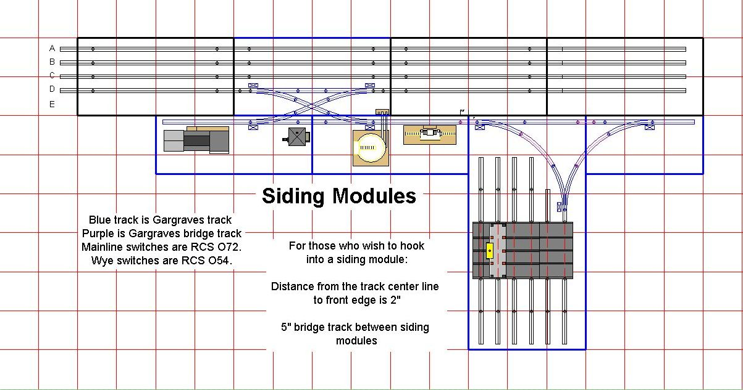

Module Standard
We used the club building standards for our new modules, but we chose to use Gargraves track along with RCS turnouts to give a more realistic look and smoother operation. The RCS turnouts are excellent and I recommend the club use these whenever possible. They seem much better than any Lionel switch I’ve played with.

The siding track sits 2 inches from the front edge of the siding module to the center rail. The siding track ends 2.5” from the module edges, thus creating a 5” bridge track. All Gargraves track.

Wiring Standard
Our modules use 6 position interlocking connectors from Radio Shack (part numbers 274-236 and 274-226). We tried these instead of Jones plugs to reduce cost and to make wiring easier. While these connectors are cheaper, they are about the same pain to solder.

Each module should have a wiring harness with a male plug on the right side (when facing out from the back side of the module), and a female plug on the left side.

We’re using standard club 18 gauge wiring for our modules.

Here is the mapping we used for our wiring harness:

Pin Number | Function | Wire Color
1 | Track Power | Brown
2 | Low Voltage Accessory | Blue
3 | High Voltage Accessory | White
4 | Common Ground | Black
5 | Turnout Power | Green

The siding transition module also provides a connector to hook the sidings up to mainline power. The following mapping was used for hooking up to mainline power:

Siding Pin | Function | Club Pin in 6 Prong Jones Plug
1 | Track Power (main line 4) | 1
2 | Low Voltage Accessory | 3
3 | High Voltage Accessory | 4
4 | Common Ground | 5
5 | Turnout Power | 6

Additionally, we have built a separate power box to power just the sidings. In the works is a switch-box that will allow selecting either club power or separate power for each function (track, low acc, high acc, and turnout).
The common ground always flows into the siding modules allowing propagation of the TMCC signal. To do this, I made sure the separate power box is in phase with the club power box.

Conclusion
We welcome other members to build siding modules that hook up to these. Our goal is to have fun, do some interesting siding operations, and provide some hi-rail feel to the club layout.

