The Express

Newsletter of the Tinplate Trackers, Austin, Texas
July/August 2002 – 36th Edition

A newsletter will be sent out every two months to the current members, past members, and visitors of the club. Please contact Steve Wise at 512-444-3310 or E-Mail him at swise@aoot.com if you have any information you would like to have included in future newsletters. All comments/submissions welcome!

From The Editor
Hello Tinplaters!

July and August have come and gone! Amid the hustle and bustle of summer non-train life, the Tinplate Trackers managed to have a club workday and an excellent run at the Burnet Rail Fair in August. Up and coming this fall is some more exciting events as well as our annual members meeting.

Hope you enjoy this issue!

Stevo.

PAST CLUB EVENTS

Club Workday – August 10th, 2002
Scott, Rick, and Steve attended the workday at Scott’s house. Despite the low turnout, they managed to make solid progress on several projects. Thanks to all who attended!

Accomplishments:

- A new shelf was added to the trailer. This shelf is above the transition modules on the left side. It will hold the 2' trolley modules, plus there is room for general storage.

- Added Plexiglas on one more corner (other small club corner). We need more supplies to complete the other two club corners.

- Fixed leg slots on one of the new corners and started on the 2nd (we quickly overheated in the august sun :-). Rick came up with the idea of just rasping them with a wood rasp. This worked well to make them larger. Since they were glued together, it would be painful to remove them and remake them. The rasping did the trick!

- Added spacers on the new corners so they don't crush track when strapped into the trailer. The problem is the cross members at each end of the "square part" of the corner modules are not recessed. So when stacked, they would press on the track of the corner module underneath. We added some small 1x2 spacers to force this gap. It didn't exactly work due to some alignment miscalculations, so we still need some minor tweaking on this.

Burnet Rail Fair – August 24th/25th, 2002
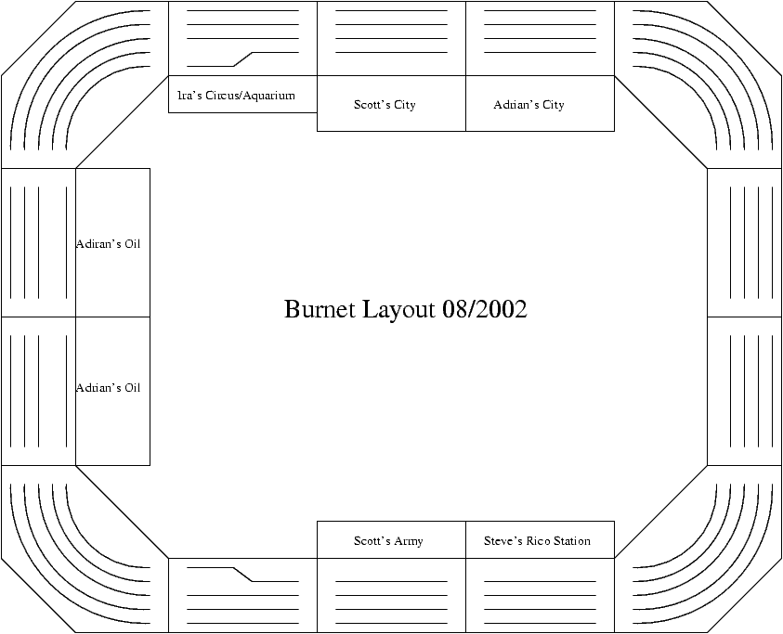
The club setup again this year at the Burnet Rail Fair in Burnet, Texas. This is the 2nd time we’ve done this event. And it was a great show. We were across the street from the main convention center in an empty restaurant building and our exhibit was the first stop for fans arriving at the train station. We setup a 3x2 layout as seen below and had several accessory scenes to make the exhibit quite interesting.

In addition to our 3x2, we had the trolley line running on the bar across from the layout proper. This worked out great, and viewers could walk along the layout and see the trolley on one side and the city/circus scenes on the other.

Lorraine Schneider ran the club raffle. We raffled off a Lionel Safari set as first prize, a train book as second place, and a free year membership to the club as a third place prize. The raffle generated a net $155 for the club. This is dollars after paying the towing fee and the cost of the raffle items! Many thanks to Lorraine for taking the time to help out!

Attendees included Adrian, Steve, Ira, Ron, Rick, Scott, Bob, Randall, and new member Dwight. Trains were run, and fun was had by all…

FUTURE CLUB EVENTS

Annual Club Meeting – September 12th, 2002
The annual Club meeting will be held at the Luby’s on MoPac and Steck on September 12th, 2002. We'll assemble at 6:00pm, eat, and have a short business meeting. An agenda will be sent out via email before the meeting. Contact Ron Fiebelkorn if you have something you want to discuss and add to the agenda. The main topics of the meeting will be to coordinate our 3 shows in October and the election of two new board members.

AMRE Train Show – October 5th/6th, 2002 &

Czhilispiel – October 26th/27th, 2002

Look for more information on these two events after our Club Meeting. Stay tuned!

Club Event Schedule
The following table shows the events and shows that the club is considering.

2002
 | DATE | SHOW | PLACE | STATUS
 | Oct 5/6 | AMRE Train Show | Live Oak | Confirmed
 | Oct 25-27 | Club Fun Run | Branch Creek Clubhouse | Canceled
 | Oct 26/27 | Czhilispiel | Flatonia | Confirmed
 | Oct 26 | Austin Jamboree | Round Rock | Confirmed
 | Nov 30/Dec 1 | GATS | Fort Worth | Canceled
 | Dec 6/7 | Club Fun Run | Branch Creek Clubhouse | Confirmed
2003
 | DATE | SHOW | PLACE | STATUS
 | Feb 1/2 | SAMRA Train Show | Live Oak | Confirmed
 | June 7/8 | GATS | Live Oak | Pending

OTHER NEWS

New Member – Dwight Edens

Saturday August 24th at the Burnet Rail Fair event, Dwight Edens became a member of TTAT. He brought a lot of nice trains with him to Burnet and ran them for several hours on our layout. Dwight lives in Rockport and ran with us last year at Flatonia. I believe he may join us again at the October shows in San Antonio and Flatonia. Several of us had a chance to talk with him Saturday and hopefully the rest of you will be able to meet him at an upcoming event.

Welcome Aboard Dwight!!!

New Austin-based Railroad Organization
At the Burnet Rail Fair we were contacted by a new model railroad organization in Austin: Keaton's Roundhouse for Children. Their goal is to bring knowledge and love of trains to Austin area children through educational and cultural programs. They want to educate children and parents about the facts, history, and lore of trains and the American
railroad system, and train safety.
They are just getting going and are starting to schedule events/activities for 2003. These include installing a few toy train layouts in patient areas of Children's Hospital, an Annual Train Song Sing-Along on Sunday, June 29, 2003 at Dougherty Arts Center, and a train writing/illustrating contest next spring. They are also in the process of developing a website (www.keatonsroundhouse.org) and e-mail address (info@keatonsroundhouse.org) for their organization.
So keep your eyes and ears open for more information about this organization. They will be looking for people with small children who love trains and would like to know about their events, people who would like to be involved with and help their organization, and of course, people who want to donate or help raise money for their organization. It sounds like a group we might be able to work with in the future.

2002 TEXAS TRAIN SHOWS

October 5th & 6th, 2002 - A.M.R.E. Train Show – Live Oak Civic Center, 8101 Pat Booker Road, Live Oak.

November 9 & 10, 2002 – GATS at the Pasadena Convention Center Complex, 7902 Fairmont Parkway, Pasadena. All GAT Shows are open to the public both days from 11am to 5pm. For more information and a $1.00 off coupon go to www.GATS.com

November 30 & December 1, 2002 – GATS at the Fort Worth Convention Center, 1111 Houston Street, Fort Worth. All GAT Shows are open to the public both days from 11am to 5pm. For more information and a $1.00 off coupon go to www.GATS.com

